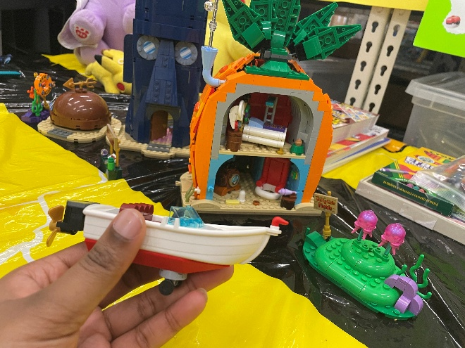
Hi! My name is Briquenne Williams, I’m a 31 year old mother of two that has had many backgrounds/hats in relation to my output. I’ve grown up basically surfing the web and found myself making a pseudo home on it. As most of my clients were mainly online I have found small ways to evolve to meet the market. Between that and my current job I used to work for Johnny Rockets as an FDR (Fountain, Dishwasher, Runner) and found myself even working at Syracuse University not too long after as a on demand Floater for the food court. Now a days I find myself thankful to work at the LEGO store, mainly focusing on the income from that versus commissions or anything else of the sort. It generally helps with decompressing after what I consider long stressful days and gives me something to bring back as a daily souvenir to my kids. In regards to my background with schooling: I went to High School in Canton, Mississippi and found myself moving to New York back in 2010. Ultimately I consider being a first generation college student like myself as having many obstacles to overcome, especially in the face of things like finding childcare and maintaining good grades to keep myself in proper standing, but I’m taking the year in stride.

